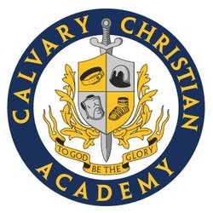

2024-2025 School Profile
CALVARY CHRISTIAN ACADEMY
CEEB: 053825

Pastor Mike McClure, Head of School 1175 Hillsdale Avenue
Jere Allen, Lower and Middle School Principal San Jose, CA 95118
Chris Garcia, High School Principal
calvarychristiansj.org

Mission: The mission of Calvary Christian Academy is to educate the whole student within a Christian context of spiritual, social, mental, and physical development. As an extension of the ministry of the Church, we exist to help students cultivate a relationship with God through Jesus Christ, to discover and encourage their gifts, and to inspire each student to realize his or her full potential in serving God in spirit and in truth.

Enrollment: Founded in 2011, Calvary Christian Academy now enrolls 281 students from grades K-12. In the Upper School, the enrollment is 66 students, the student-faculty ratio is 2:1, and the average class size is 13.

Academic Program: CCA implements a rigorous curriculum, structured after the classical trivium and consisting of three stages—grammar, logic, and rhetoric.
- Logic and Rhetoric: As students complete full-year courses, they implement acquired skills in logic and rhetoric throughout the curriculum, demonstrating cross-curricular reasoning. CCA students clearly and persuasively articulate the knowledge they acquire across departments and courses.
- Classical Texts and Primary Sources: CCA seeks to inspire students with the knowledge that they are both inheritors and responsible contributors to historical, social, and cultural contexts much greater than themselves. As part of this process, CCA students engage with classic texts and primary sources. The CCA humanities sequence includes of a study of western literature and history from antiquity to modern Europe and America.
- Classical and Modern Languages: All lower and middle school students at CCA study Latin. In the upper school, students may choose to study classical or modern languages.
- Academic Tracks: Many CCA students pursue an Honors Level diploma. At CCA, the academic program is rigorous and comparable to other Classical Christian schools.
- Advanced Placement: By design, CCA does not offer classes adhering to the Advanced Placement curriculum. In contrast, classical pedagogy entails in-depth discussion of essential questions and great works which may be limited by the AP curriculum.
- Senior Thesis: Students in grade twelve complete a senior thesis project, which serves as an opportunity for students to synthesize the CCA academic curriculum, demonstrate cross-curricular thinking, and apply rhetorical skills. Students prepare, present, and formally defend a substantive argument to a panel of faculty and guests.
- Ranking: CCA does not rank students.

Academic Honors: CCA students receive academic honors, determined by the student’s cumulative GPA.
- Summa Cum Laude: 4.0 GPA
- Magna Cum Laude: 3.75-3.99 GPA
- Cum Laude: 3.5-3.74 GPA

Grading Scale:
(unweighted - 4.0 scale)
A+ 100-98% (4.0)
B+ 89-87% (3.3)
C+ 79-77% (2.3)
D+ 69-67% (1.3)
A 97-93% (4.0)
B 86-83% (3.0)
C 76-73% (2.0)
D 60-66% (1.0)
A- 92-90% (3.7)
B- 82-80% (2.7)
C- 72-70% (1.7)
F 59% and below

Graduation Requirements – CCA Honors Diploma
Core Classes:
English – 4 courses
Math – 4 courses
Science (with labs) – 3 or 4 courses
History/Social Sciences – 4 courses
Foreign Language – 3 or 4 courses
Bible – 2 courses
Logic – 1 course
Senior Thesis – 1 course
Integrated Studies:
Fine Arts – a minimum of one course
Physical Education – a minimum of 2
courses
Electives – a minimum of 4 courses

Graduation Requirements – CCA Diploma (State Standards)
Core Classes:
English – 4 courses
Math – 3 courses
Science (with labs) – 2 or 3 courses
History/Social Sciences – 4 courses
Foreign Language – 2 or 3 courses
Logic – 1 course
Senior Thesis – 1 course

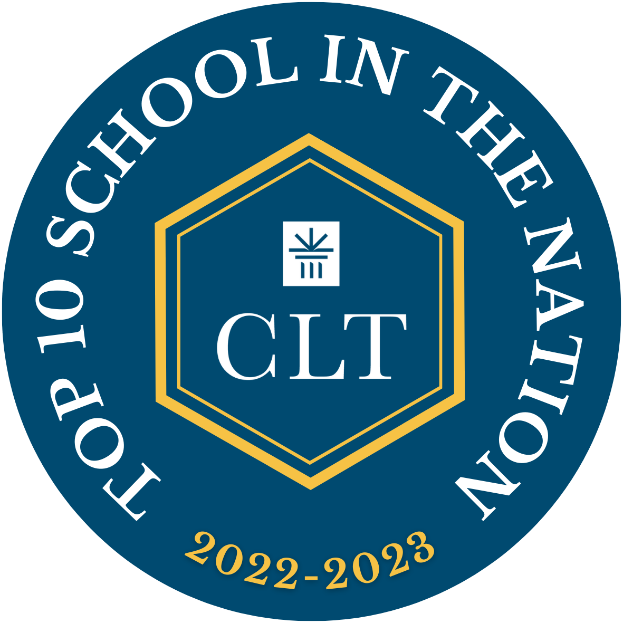
Integrated Studies:
Fine Arts – a minimum of 1course
Physical Education – 2 courses
Electives – a minimum of 3 courses
Calvary Christian Academy, San Jose was named one of the top ten schools in Classic Learning Test’s (CLT) 2022-2023 CLT School Rankings. This award recognizes Calvary Christian Academy’s student body for collectively receiving one of the highest average scores in the nation on the CLT during the 2022-2023 academic year.

CCA Rhetoric School – Selected Reading List

Pilgrim’s Progress, John Bunyan
The Beautiful and Damned, F. Scott Fitzgerald
The Garies and Their Friends, Frank J. Webb
Animal Farm, George Orwell
The American Story: The Beginnings, David
Barton
The Iliad, Homer
The Odyssey, Homer
Media, Euripides
The Aeneid, Vergil
The Metamorphoses, Ovid
The Republic, Plato
Beowulf, unknown
The Consolation of Philosophy, Boethius
The Divine Comedy, Dante Alighieri
Romeo and Juliet, William Shakespeare
Twelfth Night, William Shakespeare
The Merchant of Venice, William Shakespeare
Henry V, William Shakespeare
Hamlet, William Shakespeare
Macbeth, William Shakespeare
Paradise Lost, John Milton
Paradise Regained, John Milton
City of God, St. Augustine
Persuasion, Jane Austen
Jane Eyre, Charlotte Brontë
Great Expectations, Charles Dickens
Frankenstein, Mary Shelley
The Picture of Dorian Gray, Oscar Wilde
All Quiet on the Western Front, Erich Remarque
Four Quartets, T.S. Eliot

Selections From:
Early American Poetry
Nathanial Hawthorne, Selected Stories
Edgar Allan Poe, Selected Stories
“Self-Reliance,” Ralph Waldo Emerson
Democracy in America, Alexis de Tocqueville
The Autobiography of Benjamin Franklin
On Liberty, John Stuart Mill
The Federalist Papers
The Anti-Federalist Papers
Politics, Aristotle
Symposium, Plato
Eclogues, Vergil
Georgics, Vergil
Poetry of Horace and Catullus
The Prince, Machiavelli
Poetry of Wordsworth, Keats, and Coleridge

